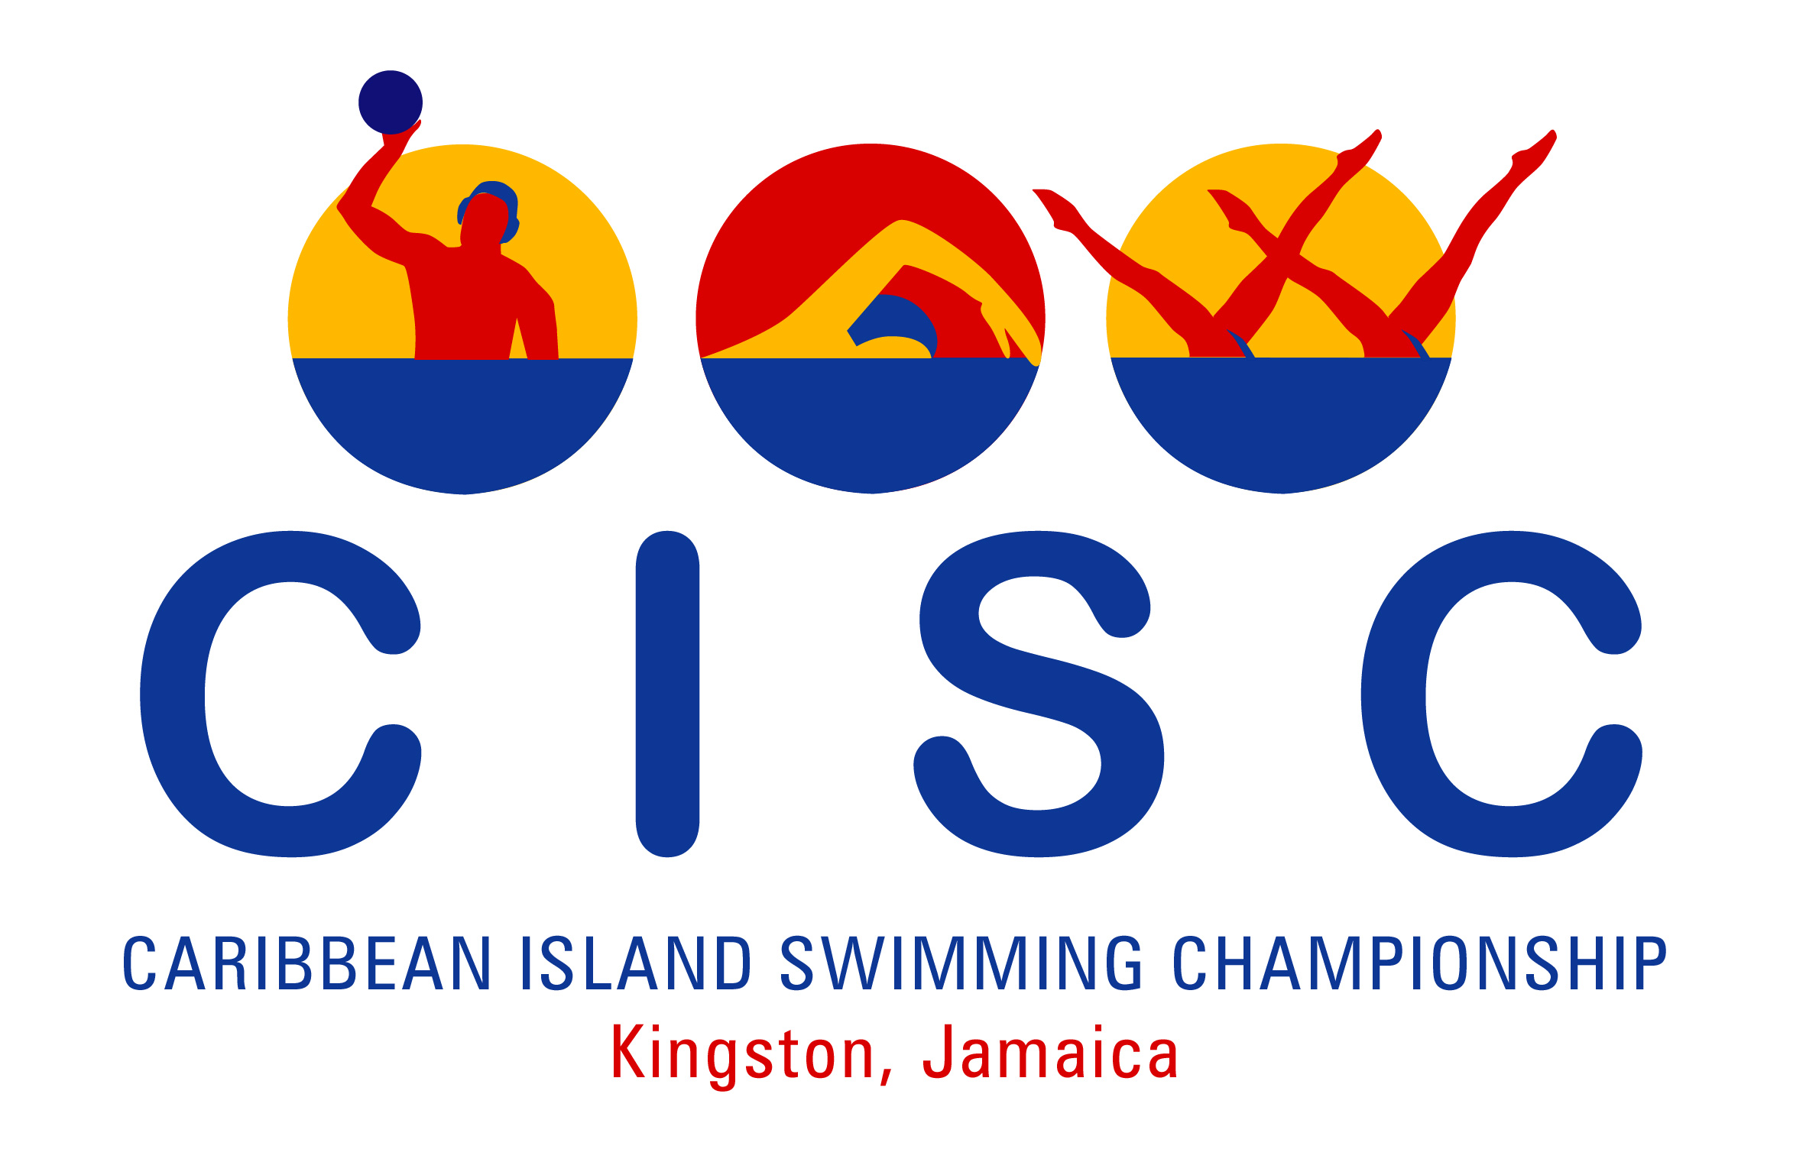
2008 Caribbean Island Swimming Championships
National Stadium Pool
Kingston, Jamaica
July 16 – 23, 2008

METHOD OF PAYMENT

- WIRE TRANSFER:

The National Commercial Bank Jamaica Limited
1-7, Knutsford Boulevard,
Kingston 5
Jamaica
Swift Number JNCBJMKX
For Credit to Account No. 354249677 in the name of Carifta Aquatics Limited

2. CREDIT CARDS

NAME:_______________________________________________________
HOME ADDRESS: _____________________________________________
MAILING ADDRESS: ___________________________________________
HOME PHONE: ___________________WORK PHONE: ______________________
FAX #: ______________________ E-MAIL: ______________________________

NAME OF BANK (on which card drawn):_________________________________
ADDRESS OF BANK: ___________________________________________
STATEMENT ADDRESS: [ ] Home [ ] Mailing [ ] Other
If other please specify ______________________________________________

TYPE OF CARD: [ ] Visa [ ] Master Card
Name as it appears on Credit Card: _______________________________
Credit Card # ________________________________
Exp. Date: _______________ Auth. # ________ (3 digit number on back of card)

CREDIT CARD AUTHORIZATION

I authorize Carifta Aquatics Limited to charge to my credit card the sum of US$___________ representing deposit for the 2008 Caribbean Island Swimming Championships, Kingston, Jamaica.

_________________________________________ Date:___________________
CARD HOLDERS SIGNATURE – REQUIRED

Important note:
Credit card verification is required at accreditation, that is presentation of the Credit Card along with photo identification (driver’s license or passport of the cardholder). Please complete and return this form by fax to the ASAJ Office at (876) 920-6129.

